Reynolds Resource Development
Regional Food Security Initiative
――――――――――――――――――――――――――――――
“Engineering Tomorrow’s Food Systems Today”

Prepared by:
Robert Reynolds, Chief of Operations
Reynolds Resource Development

Program Focus:
Sustainable Food Systems • Energy-Efficient Greenhouse Design •
Regional Co-op Development

📧 robert@reynoldsresourcedevelopment.com
🌐 https://reynoldsresourcedevelopment.com

“For the Generations We’ll Never Meet”

Engineering Tomorrow’s Food Systems Today

Why is this important? What do we offer? What are our goals?

Why this is important:
• America imports most of its fresh produce; costs and supply are volatile.
• Our design cuts energy by up to 60% and stabilizes year-round growing.
• Ozark proof-of-concept becomes a repeatable model for any region.

What we offer:
• Passive-solar greenhouses with GAHT® + R-40 insulated envelope (3,000 & 9,000 ft²).
• Standardized modules for rapid build; co-op distribution to schools and hospitals.
• Energy savings pay down the loan; produce sales add steady cashflow.

Key metrics (3,000 ft² module):
• CAPEX ≈ $246K | Energy Savings ≈ $23K/yr | Payback ≈ 8–10 yrs
• People fed ≈ 800–1,000/yr; positive cashflow with 3% ag loan (15-yr).
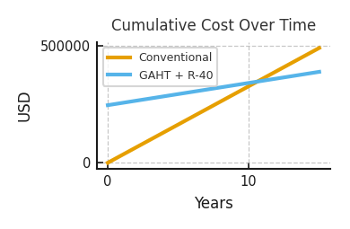
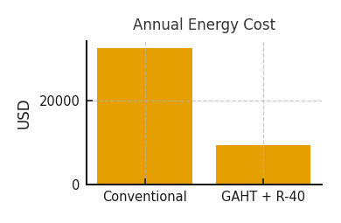

Poultry Transition Pathway (Farmer Example):
• One grower deploys 9 modules (≈27,000 ft²) — comparable footprint to 3 chicken houses.
• People fed ≈ 7,200–9,000/yr; energy cost avoided ≈ $207K/yr vs. conventional greenhouses.
• Cluster CAPEX ≈ $2.2M; 10–15% bulk savings improve cashflow from Year 1.

Join the movement:
Partner with us to deploy the first two Ozark sites and seed a national model.

🟡 View Full Program at https://reynoldsresourcedevelopment.com
Robert Reynolds | Chief of Operations | robert@reynoldsresourcedevelopment.com
© 2025 Reynolds Resource Development

